**CHEG401 - Chemical Process Dynamics and Control**

**Lab 1 - Implementing Process Model Equations in Simulink**

Li Pei Soh

Linh Nguyen

Khai Khee Kho

Abdul Fayeed Abdul Kadir

September 30th, 2021

College of Engineering, Department of Chemical and Biomolecular Engineering

University of Delaware

Newark, Delaware 19711

**Part I: Liquid level Dynamics in Storage Tank**

1. **Transfer function *g(s)* for the process.**
$A_{c}\frac{dh(t)}{dt} = F_{i}(t) - ch(t) (1)$

$Define: y(t) = h(t) - h^{*}, u(t) = F_{i}(t) - F_{i}^{*}$

$At steady state: 0=F_{i}^{*}-ch^{*} (2)$

$(2)-(1): \frac{dy(t)}{dt}=\frac{-c}{A_{c}}y(t)+\frac{1}{A_{c}}u(t)$

$ℒ\left\{\frac{dy(t)}{dt}\right\}=sY(s)-y(t=0)=-\frac{c}{A_{c}}Y(s)+\frac{1}{A_{c}}U(s)$

$Y(s)\left[s+\frac{c}{A_{c}}\right]=y(t=0)+\frac{1}{A_{c}}U(s)$

$Y(s)=\frac{y(t=0) + \frac{1}{A_{c}}U(s)}{s+\frac{c}{A_{c}}}, y(t=0)=0$

$Y(s)=\frac{\frac{1}{A_{c}}U(s)}{s+\frac{c}{A_{c}}}=\frac{U(s)}{A_{c}s + c}$

$Y(s)=g(s)⋅U(s)$

$A_{c}=1.5, c=0.5$

$g(s)=\frac{1}{1.5s + 0.5}=\frac{2}{3s + 1}$

2. **Response of the system to the step increase in *Fi* stipulated using SIMULINK.**

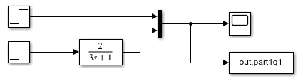

**Figure 1.** SIMULINK setup for step change from 2 m3 to 5 m3.

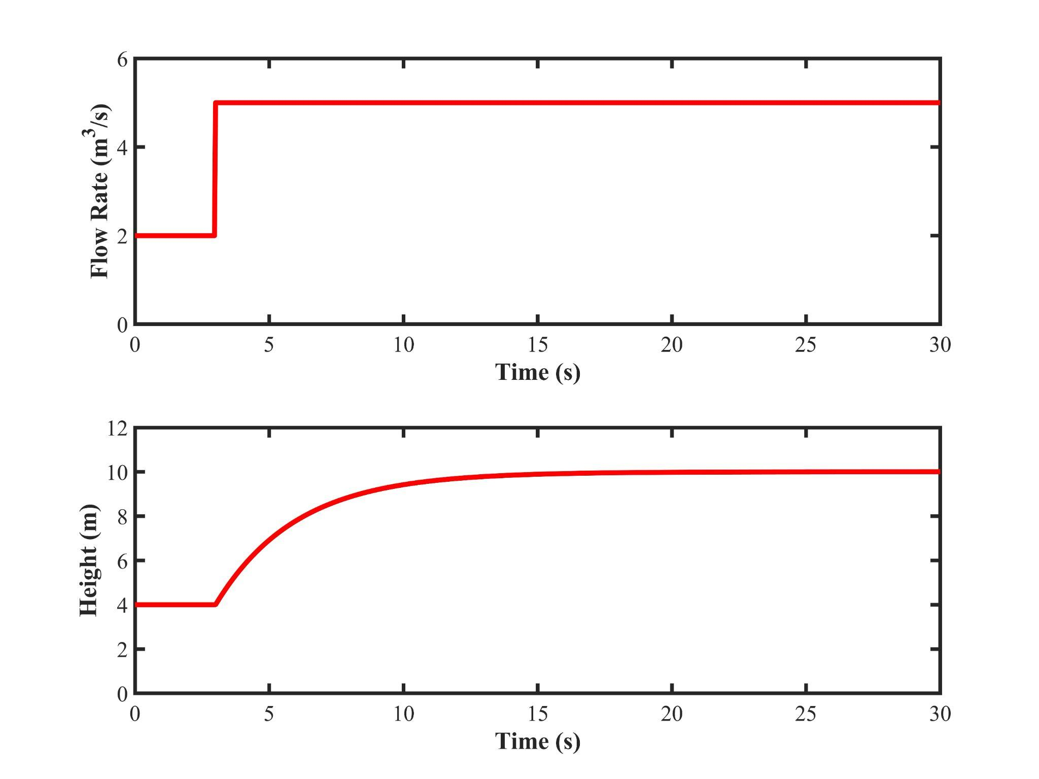

**Figure 2.** MATLAB plots for step change from 2 m3 to 5 m3.

1. ***What is the resulting steady state value of the liquid level following the step input? Which parameter(s) determine how the steady state liquid level is related to the inlet flow rate?***

The resulting steady state value of the liquid level is 10 m.

Parameters determining steady state liquid level are the steady state gain (K) and input step magnitude. The larger the step input of the flow rate, the higher level of height the liquid reaches.

1. ***How long does it take to reach steady state (when the response is roughly 95-98% completed)? Which parameter(s) determine this time?***

It takes about 10.46 to 13.20 s for the response to reach 95 - 98% of the steady state value (10 m).

Parameters determining the time to reach steady state are the maximum height and the residence time (𝜏).

1. **Rectangular pulse with the same magnitude but different durations.**

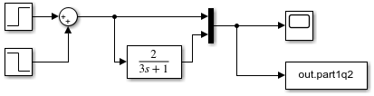

**Figure 3.** SIMULINK setup for the rectangular pulse response

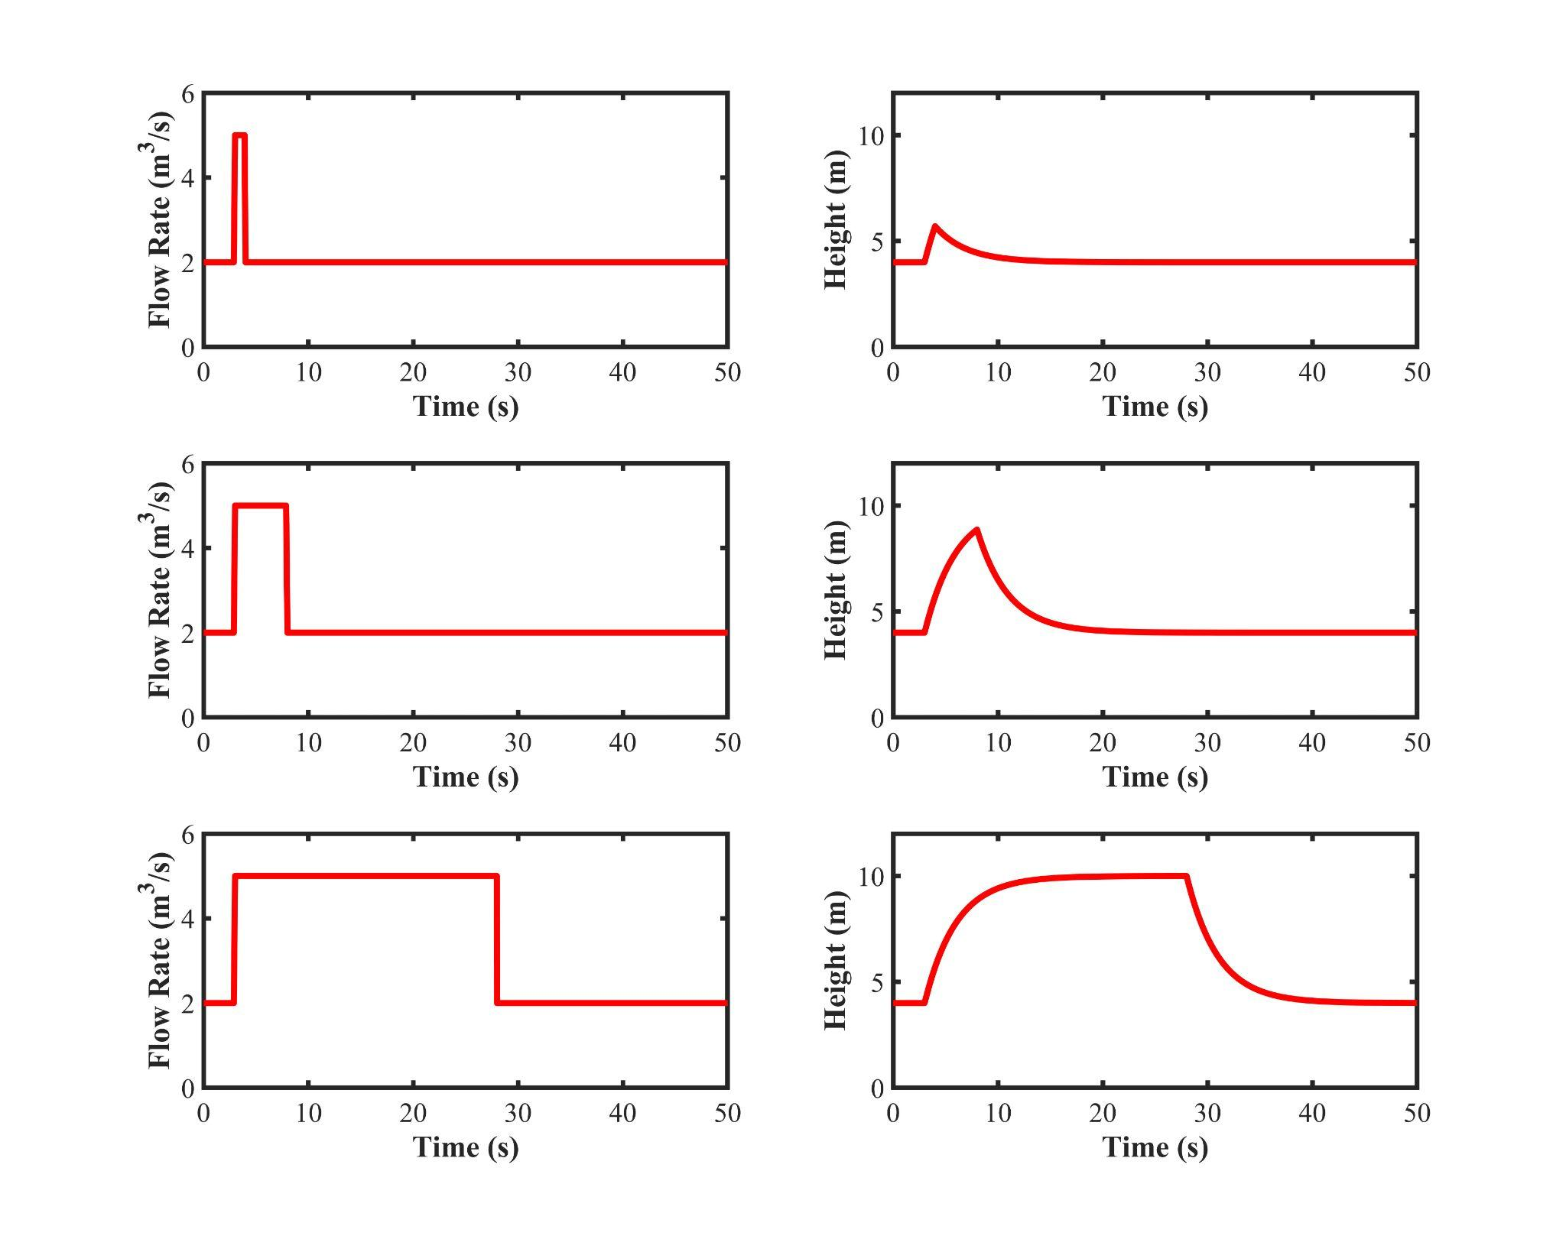

**Figure 4.** MATLAB plots for rectangular pulse. The first, second and third rows represent the pulse duration of 1, 5, and 25 seconds respectively.

1. ***Each of these plots is the result of a rectangular pulse of the same magnitude change in flow rate. Why do they exhibit different shapes?***

The difference in shapes are due to the difference in rectangular pulse durations. The longer the duration of the pulse, the higher the liquid level rises. If the pulse duration is long enough (as seen in the plot of 25 s duration for height response), the liquid level will reach the equilibrium height (at 10 m), before it decreases as the pulse decreases.

1. ***Without carrying out a simulation, strictly from theoretical considerations, what do you expect to be the minimum an input pulse width must be in order for the liquid level response to reach the highest possible value? What do you expect this highest possible value to be?***

The general equation for y(t) with $u(t)=Aδ(t)$ is an unit impulse is:

$y(s) = \frac{KA}{τs+1}$

$y(t) = \frac{AK}{τ}*e^{-\frac{t}{τ}}$

The impulse response indicates an immediate jump to value $\frac{AK}{τ}$ at the beginning and followed by an exponential decay. Therefore, the maximum height is $\frac{AK}{τ}$. From the transfer function g(s) = $\frac{2}{3s + 1}$ which indicates K = 2 and $τ$ = 3. Therefore, $A = maximum height ×\frac{τ}{K} = 10 m ×\frac{3 s}{2 m} = 15 seconds$.

1. **Pulse with two consecutive “up” steps.**

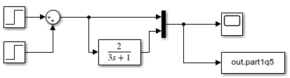

**Figure 5.** SIMULINK setup for two consecutive “up” steps.

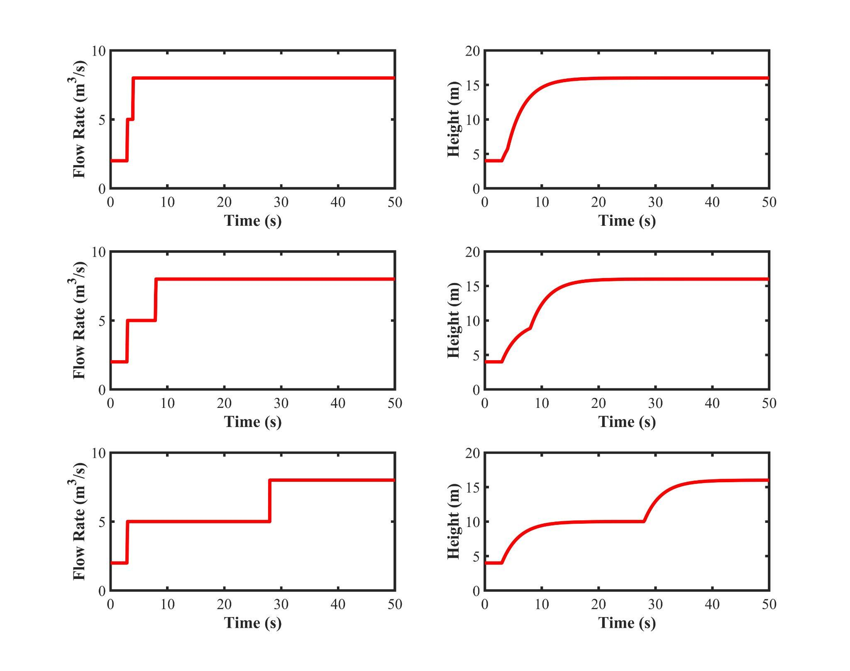

**Figure 6.** MATLAB plots for rectangular pulses with two consecutive “up” steps. The first, second and third rows represent the pulse duration of 1, 5, and 25 seconds respectively.

1. ***Are the responses linearly additive? Why or why not?***

The responses are linearly additive if and only if the liquid level reaches steady state for each pulse step. As transfer function can only be applied to linear systems, step increases are independent of time.

1. ***Would a gravity-draining tank in the real world behave this way? If not, how would it behave? Support your answer adequately with an equation or some other clear explanation.***

The gravity-draining tank will not behave in such a way in the real world. In the real world, gravity flows are proportional to the square root of the height of liquid in a tank. $A_{c}\frac{dh}{dt}=F_{i}(t) - c\sqrt{h(t)}$

1. **Sine wave pulse input.**

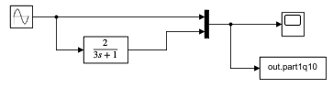

**Figure 7.** SIMULINK setup for sine wave.

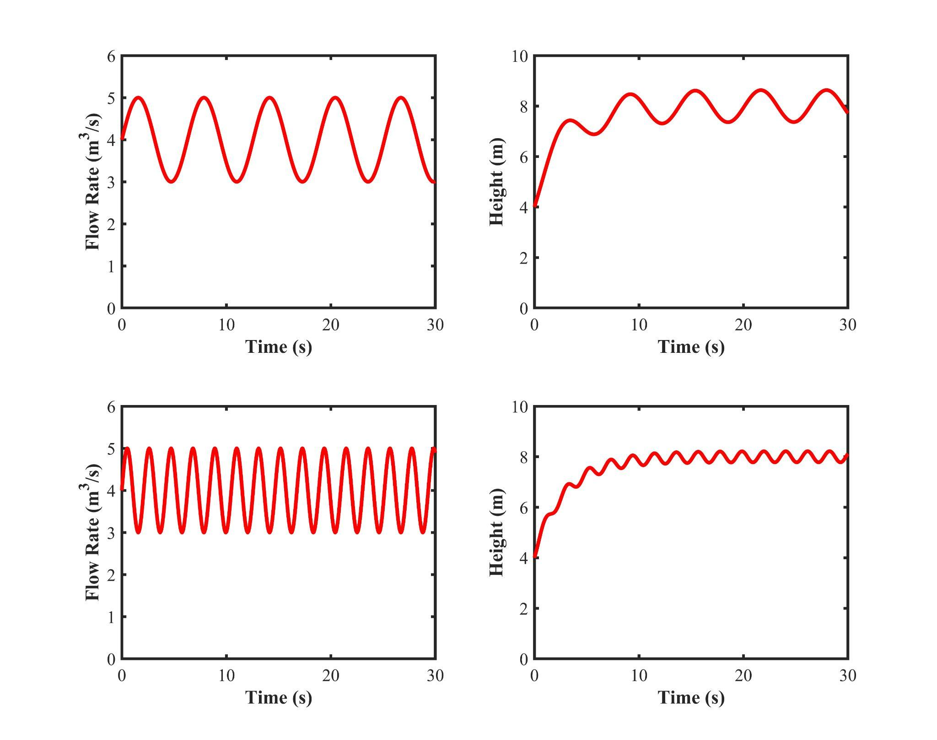

**Figure 8.** MATLAB plot for sine wave. The first and second rows represent the pulse with 1 and 3 rad/sec respectively.

1. ***What is the Phase lag (delay) of the input relative to the output in each plot? Answer in terms of degrees (π = 180◦. One full sine cycle is 2π).***

$ϕ = tan^{-1}(-ωτ)$

For frequency of 1 rad/s, the phase lag is -71.6o

For frequency of 3 rad/s, the phase lag is -83.7o

1. ***Do the two plots exhibit the same lag (delay)? Why? Support your answer adequately***

No. Phase lag depends on the frequency. Because the two scenarios have two different frequencies, the phase lags should be different.

1. ***Compare the two output plots. How does the amplitude of the output change as the frequency of the input changes? Why?***

As the frequency of the input increases, the amplitude of the output decreases.

From **Figure 8**, it was observed that as the frequency of the inputs increases, the amplitude of the output decreases. Physically, this makes sense because if the flow rate frequency changes more often, the height of fluid in the tank has less time to react to the changes, which causes the height to fluctuate in a smaller amplitude.

1. ***If we were to increase the input frequency to infinity while keeping the input amplitude at the same finite value, what would you expect the output response to look like? Support your answer with an equation or clear explanation. You can try this proposition with SIMULINK, but the graph will probably be too busy to provide clear insight.***

The output will become a smooth curve. In a similar explanation for part c, as the flow rate frequency becomes larger, the liquid level in the tank has less time to react to the input changes, which leads to less fluctuation (smaller amplitude) in the liquid level. Therefore, as the input frequency heads towards infinity, the graph for the height will eventually become a smooth curve.

**Part II: Dynamics of a Spring-Shock Absorber System**

1. **Characteristics of the mechanical system**

With the deviation variable defined by $y(t)=x(t)-x{}_{0}$, the given model can be rewritten as:

$m\frac{d^{2}x(t)}{dt^{2}}+c\frac{dx(t)}{dt}+kx(t)=u(t)$

$m\frac{d^{2}y}{dx^{2}}+c\frac{dy}{dt}+ky=u(t)$

Derivation of *g(s)*:

$ℒ\left\{m\frac{d^{2}y}{dx^{2}}+c\frac{dy}{dt}+ky = u(t)\right\}$

$m[s^{2}Y(s)-sy'(0)-y(0)]+c[sY(s)-y(0)]+kY(s) = U(s)$

$s^{2}mY(s) + scY(s) + kY(s) = U(s)$

$Y(s)=\frac{1}{s^{2}m+sc+k}U(s)$

$Transfer function, g(s)=\frac{1}{s^{2}m+sc+k}=\frac{1}{s^{2}+4s+2}$

$K=\frac{1}{k} in \frac{s^{2}}{kg} ; τ=\sqrt{\frac{m (kg)}{k (kg/{s^{2}}_{})}} in s ; ζ=\sqrt{\frac{c^{2}(kg^{2}/s^{2})}{4mk (kg*kg/s^{2})}}$ is unitless

1. ***How many poles and zeros does the transfer function have?***

The transfer function has 2 poles ( $-2+\sqrt{2}, -2-\sqrt{2}$) and has no zeros.

1. ***What is the order of this process?***

This is a second-order process.

1. **Investigate the system response to a step change in u(t)**

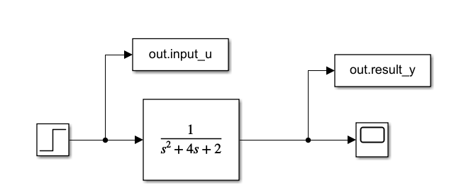

**Figure 9**. SIMULINK setup for spring-shock absorber system.

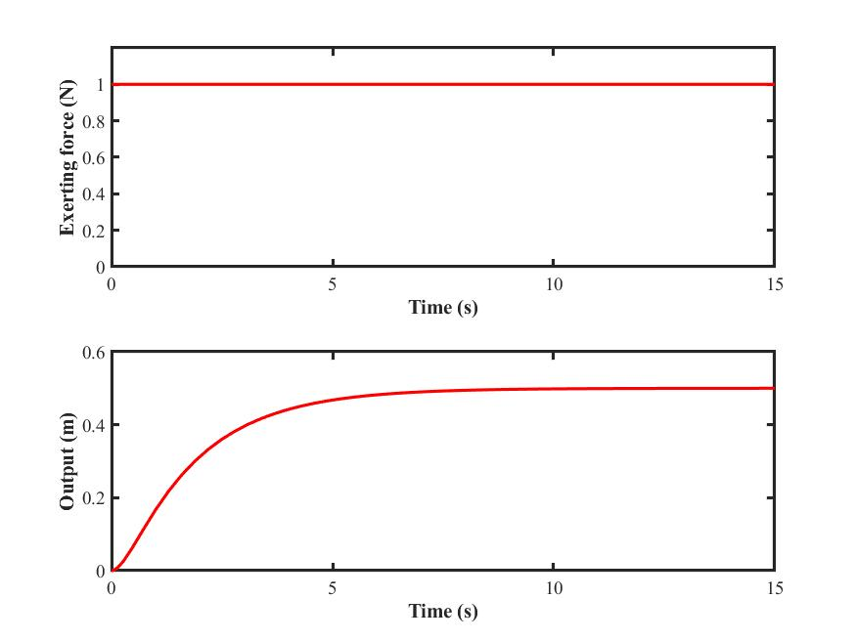

**Figure 10**. MATLAB plot for input (exerting force) and output (change in displacement of spring-shock absorber system).

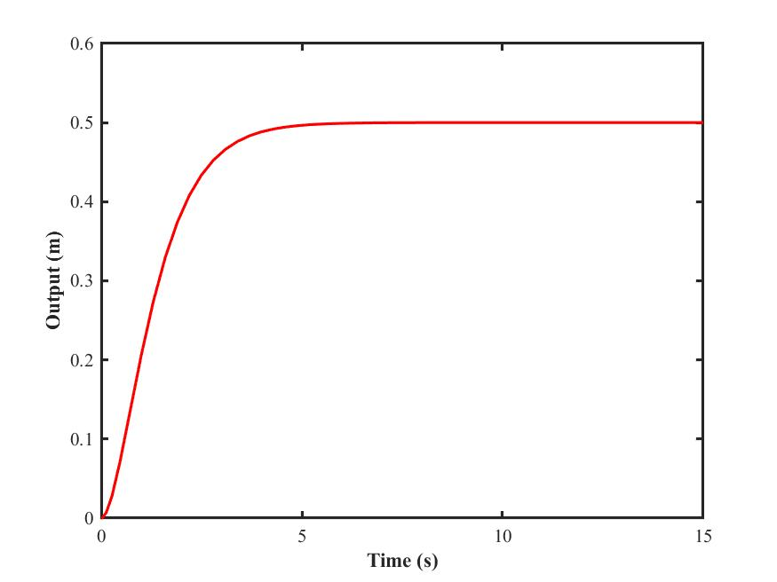

**Figure 11**. MATLAB plot of critically damped system (begin to oscillate).

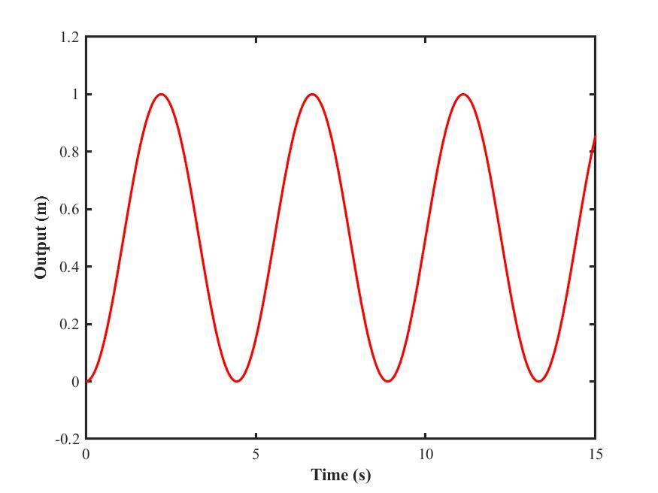

**Figure 12**. MATLAB plot of system on the verge of sustained oscillation.

1. ***Which parameters, K , $τ$, ζ contribute to the shape of the response?***

Gain, K and damping coefficient, ζ contribute to the shape of the response. Because the K will affect by how much the system responds and ζ will affect the degree of oscillation in a process response after perturbation.

1. ***Which parameters K , $τ$, ζ contribute to the speed of the response?***

$τ$ contributes to the speed of the response.

1. ***At what value of c and ζ does the system just begin to oscillate? (At this point, the system is said to be “critically damped”).***

The system begins to oscillate when c = 2.828 and the corresponding ζ = 1. Refer **Figure 11**.

1. ***At what value of c and ζ is the system on the verge of sustained oscillation?***

When c = 0 and its corresponding ζ = 0, the system is on the verge of sustained oscillation. Refer **Figure 12**.

1. ***If you were able to choose a value for ζ by design in order to control this second-order system most easily and quickly, what value would you choose? Why would you choose this value?***

I would choose ζ = 1 because the critically damping response gives the fastest return of the system to its equilibrium position.

**APPENDIX**

All plots were generated in MATLAB and SIMULINK. The codes can be found [here](https://drive.google.com/drive/folders/1jYaMvlCwe4yEiiyXXVKx-L07KJIrp_W1?usp=sharing).